**Task 2-ChatGPT**

**Differences Between Inline, Internal, and External CSS:**

**Inline CSS:**

* CSS is applied directly within the HTML element using the style attribute.
* **Example:**

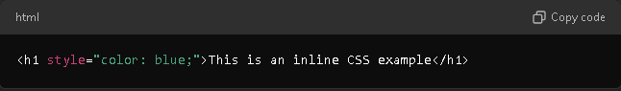

• **Advantages:**

* Easy to apply CSS quickly for a single element.
* Useful for small changes without affecting other elements.

• **Disadvantages:**

* Not reusable across multiple elements.
* Harder to maintain, especially in large documents.
* Does not separate style from content, reducing readability.

**Internal (Embedded) CSS:**

* CSS is placed within a <style> block inside the <head> section of the HTML file.
* **Example:**

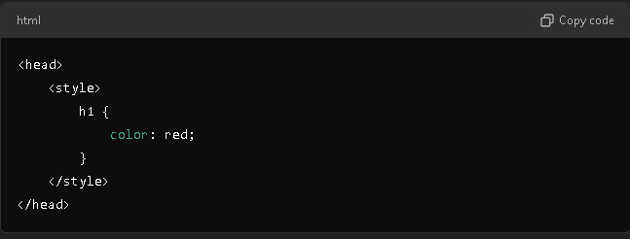

• **Advantages:**

* + Styles are kept in one place within the HTML file, making it easier to apply consistent styles to multiple elements.
  + No need to create an external stylesheet for small projects.
* **Disadvantages:**
  + Styles are limited to that specific HTML document, not reusable across different pages.
  + Can clutter the HTML file if there are many styles.

**External CSS:**

* CSS is written in a separate .css file and linked to the HTML document using the <link> element.
* **Example:**

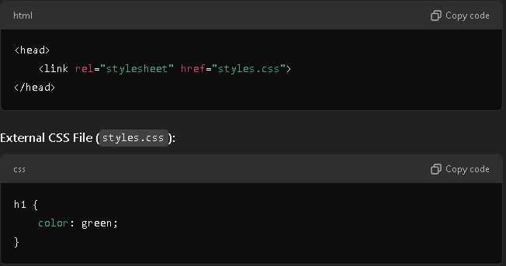

* **Advantages:**
  + Keeps the HTML file clean and separates content from styling.
  + Styles can be reused across multiple HTML documents, improving consistency and maintainability.
  + Easier to manage and maintain in larger projects.
* **Disadvantages:**
  + Requires an additional HTTP request to load the CSS file, which might slightly affect performance.
  + Not suitable for small projects where only minimal styling is needed.

Example HTML Page Demonstrating All Three Methods:

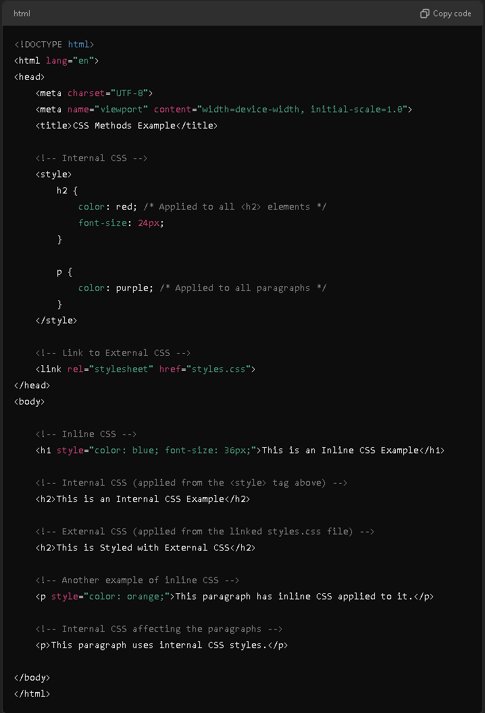

(External CSS File):

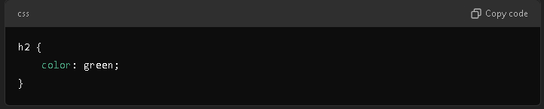

**Explanation:**

1. **Inline CSS Example:**
   * The <h1> element and the first <p> element have their styles directly applied within the tag itself, changing their color and font size.
2. **Internal CSS Example:**
   * The <style> block in the <head> defines styles for <h2> and <p> elements. These styles are applied to elements within the same HTML file.
3. **External CSS Example:**
   * The second <h2> element's style is controlled by the external styles.css file. This allows for reuse of styles across multiple HTML files.

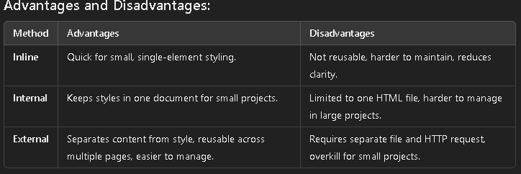

Result :

